THE 4 PILLARS OF ENTERPRISE AI
How All 4 Connect
EX: Think of these 4 concepts as building an “AI brand marketing assistant” for your business:
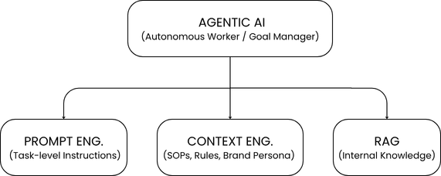

- Context engineering tells the AI who it is and how to act – like a job description.
- RAG gives it access to your company's own files and data – like a filing cabinet it can search.
- Prompt engineering gives it the specific task to do – like a daily to-do note.
- Agentic AI is what actually does the work on its own – like an employee who takes the goal and runs with it.
1. Retrieval-Augmented Generation (RAG)
Definition: A framework that connects Large Language Models (LLMs) to external, authoritative business databases without requiring expensive model retraining.
RAG lets the AI look things up in your company's own documents instead of guessing from what it already knows.
Why it's useful:
- Cheaper - you just update the documents, no need to retrain the AI.
- More accurate - answers are based on real company data, not made up.
- Safer - your private data stays protected; it's not fed into a public AI model.

2. Prompt Engineering
Definition: The practice of structuring, refining, and designing text inputs to guide LLMs toward accurate, high-quality, and formatted outputs.
This is just writing clear instructions for the AI, so you get the output you actually want.
A simple formula to remember: Role + Task + Context + Rules + Format.
Two easy tricks:
- Show examples – give the AI 1-2 samples to copy the style of.
- Ask it to think step-by-step – helpful for anything that needs reasoning, like numbers or strategy.
3. Context Engineering
Definition: The systematic management of the entire information environment around an AI model (memory, system messages, conversation history, and dynamic rules).
This is about managing everything the AI needs to remember and follow – not just one task, but the whole environment around it (memory, rules, and past conversation).
Why it matters:
- Keeps the AI from "forgetting" instructions in long conversations.
- Keeps its tone, brand voice, and safety rules consistent every time.
Simple way to remember the difference: Prompt engineering = one memo. Context engineering = the whole company rulebook.
4. Agentic AI
Definition: An advanced AI architecture capable of autonomous decision-making, planning, tool usage, and execution to achieve high-level goals.
This is AI that can work on its own – not just answer one question, but take a goal and get it done.
How it works: it gets a goal → makes a plan → uses tools to help (like RAG or a calculator) → checks its own results → fixes mistakes → repeats until done.
Why it matters for business: it lets a company get more done without having to hire more people to do it.

